Learning Story about Our Body Inquiry Conducted October & November 2015
What does your skin hold in? How do your feet grow? When it comes to our bodies, there is much to wonder, and even more to understand: A perfect topic for our first class inquiry!
The first inquiry of a school year at the Child Study Centre Junior Kindergarten (CSCJK) typically lasts six weeks. We start to focus our attention and then explore the topic. After several weeks, the children determine what they are interested in and how they wish to represent their understanding. Inquiries focus on the process of learning and making connections with outside sources of knowledge. The exciting (and unnerving) aspect of an inquiry is when we begin; we do not know how it will end!
“Mr. Bones”, a six-foot tall, 2-dimensional, plastic skeleton, initiated the children’s focus on studying the body. The children created crayon rubbings of his bones and then created an observational drawing of him. These activities introduced the vocabulary: skeleton, bones, skull, shoulder blades, ribs, hips, legs, arms, hands, and feet.
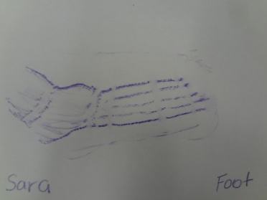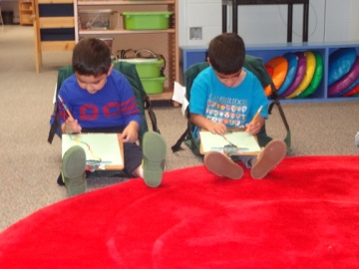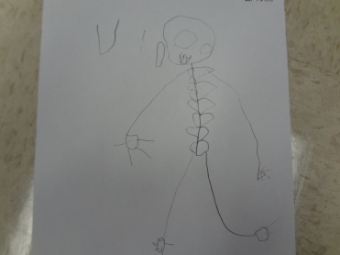
At the same time, the dramatic play area became a Doctor’s Office, and the children quickly demonstrated their knowledge through play. The children created a checklist of items to place in the play area. The props were simple: posters, a stethoscope (heart & lungs), an otoscope (ears, nose & eyes), thermometer and blood pressure gauge. At first the children and teachers took turns being the doctor, the receptionist, and the patient.
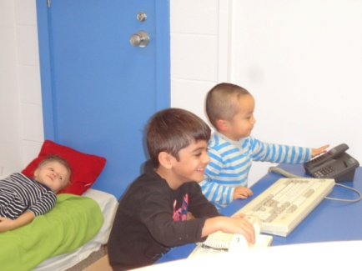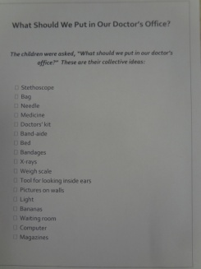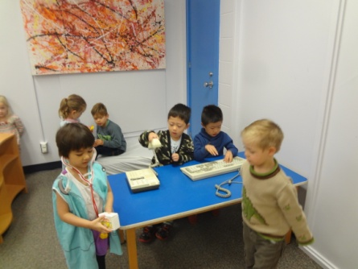
Then a weigh scale, height chart, and plastic babies (patients) were added. Eventually, the focus changed to caring for hurt bones and different pads, bandages, tools, x-rays, crutches and casts were available. The dramatic play area was definitely a central part of our inquiry.
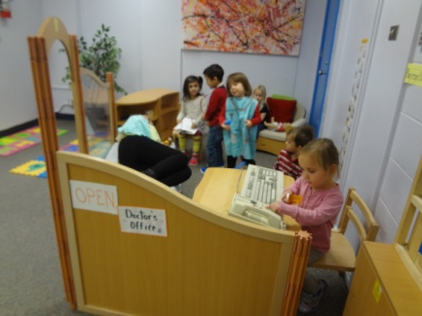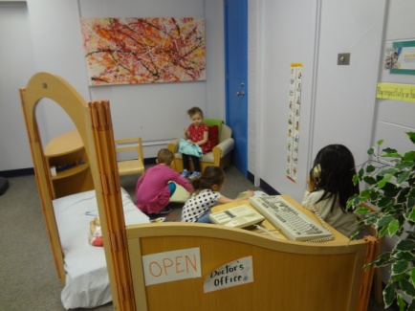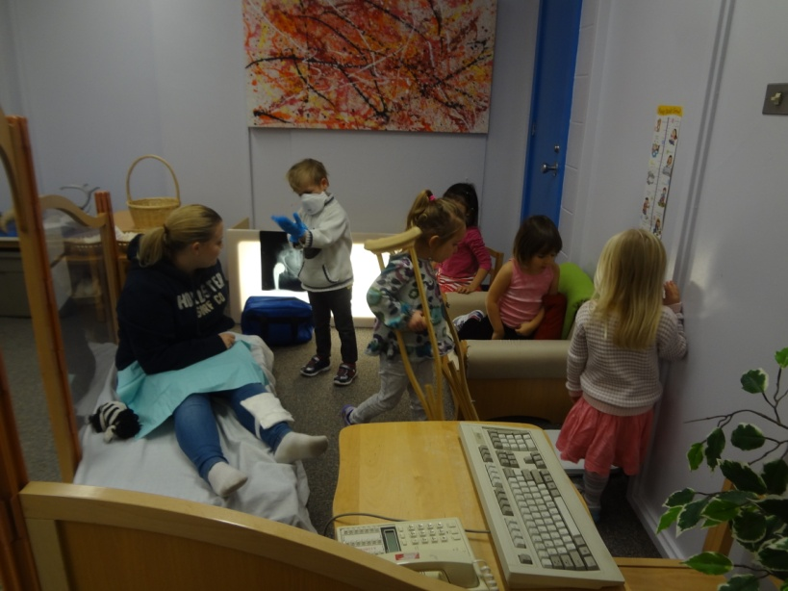
The children also participated in many activities that explored their bodies. They took turns participating in foot print painting during self-directed learning time and made a set of finger prints. In addition, body books were read and inspired us to discuss how our bodies were the same and different.
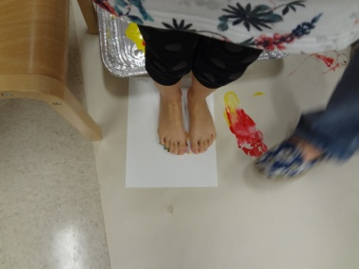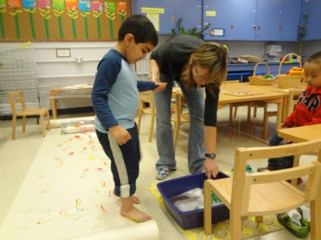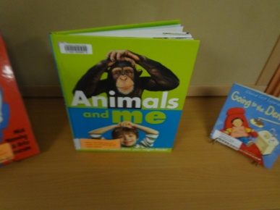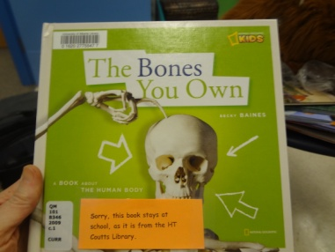
When the children realized they all had feet, but not all the same size, we created a bar chart. Charting was a new concept so first we sorted our shoes by size, then we charted on a small white board, lastly we created one on paper. It is essential to bridge the concrete (shoes) with the abstract use of the numbers; therefore, there were many steps. Using children’s photos helped make the chart relevant. Charts are cool - they convey a great deal of information!
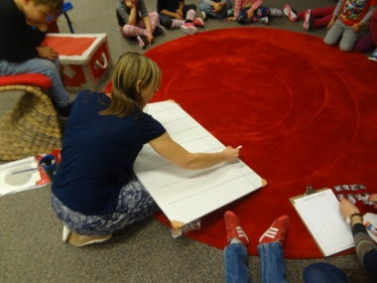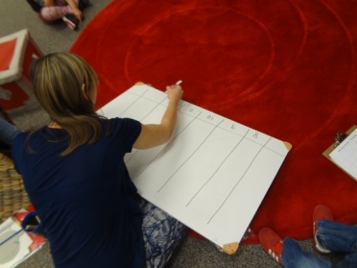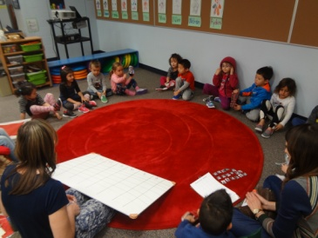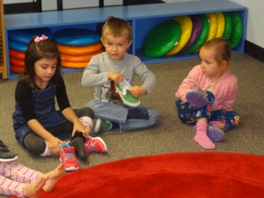
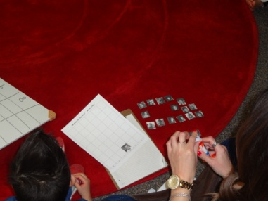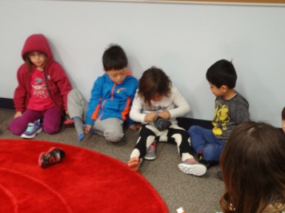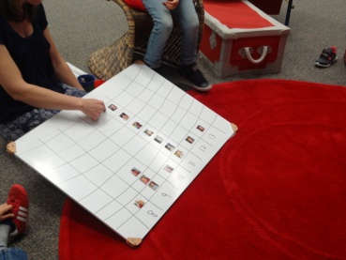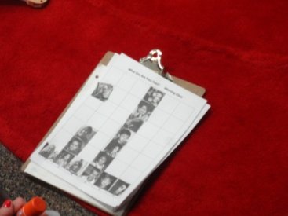
We charted hair color too, and noted that many people had brownie-black or brownie-blonde hair; consequently, the children picked which column they wanted their photo to be in. One child explained that her mom put lemon juice in her brown hair to make it more blonde – proud of her blond tips; she placed her photo in the blonde column!
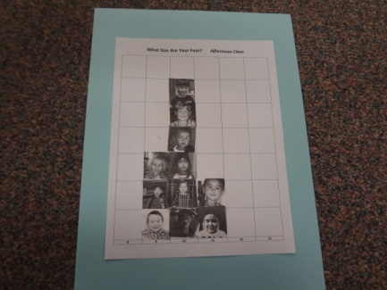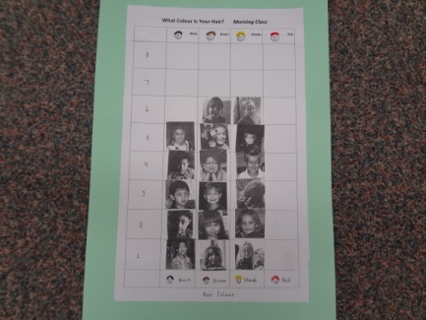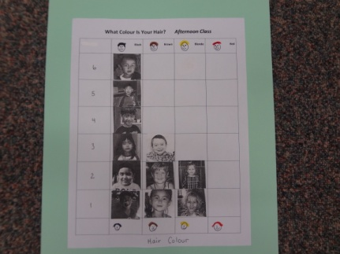
In addition, the children gained a general understanding of height. “LOOK, we’re the SAME!!”
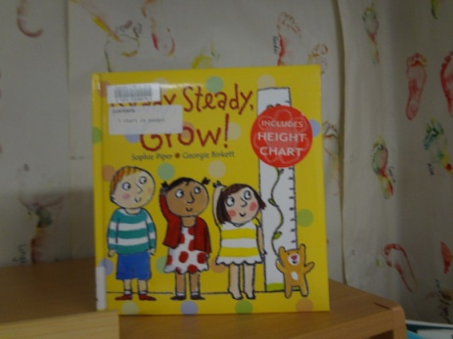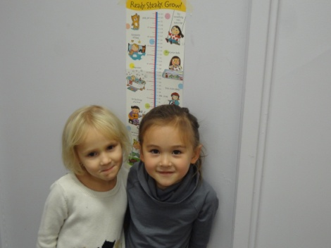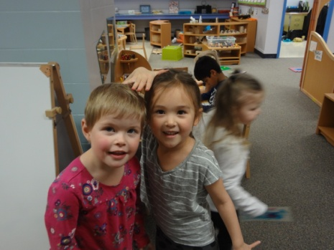

The Coutts Library graciously lent us several models of body parts: a heart, the skull, the brain, an eye, an ear, a skeleton, and a kidney. We were able to carefully inspect most of these and find more information in books.
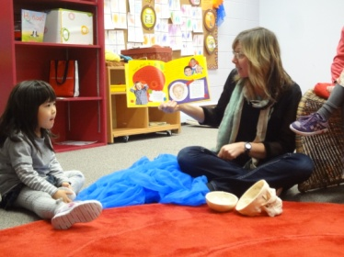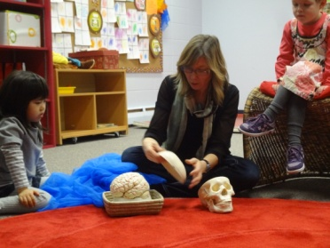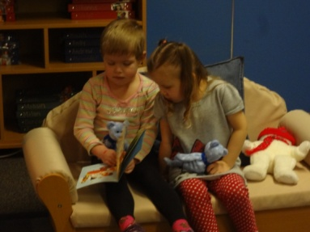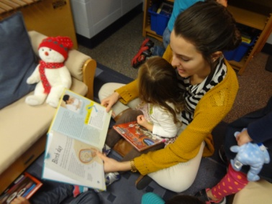
Children were asked to bring show-and-share items that related to our body inquiry: We were not disappointed! This generated a great deal of excitement, as what is interesting to one child is often very interesting to the group! Some items were placed in our class BODY MUSEUM where the children could continue to look at them.
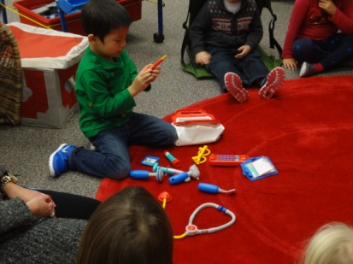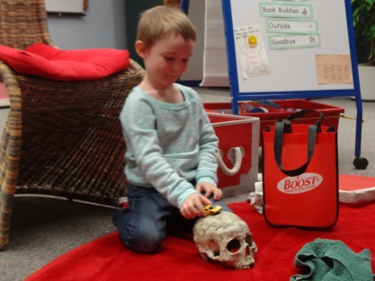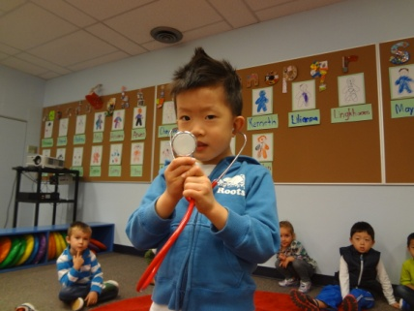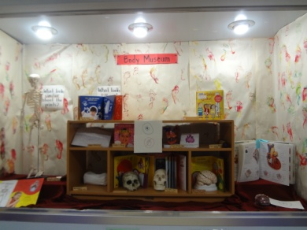
When looking at a child’s baby book, the children announced when seeing a foot of her baby feet, “Aw, how cute!” They were asked how their classmate’s feet had grown. One child stated, “You need food to grow.” Another said, “Well, your feet grown INTO your shoes.” The next day, a student explained to the class that your bones stretch as they grow. BRAVO!! A short video was watched that had photographed a girl growing from birth to 12-years of age: Growing is like magic!
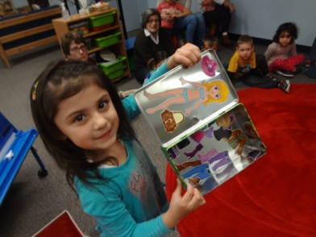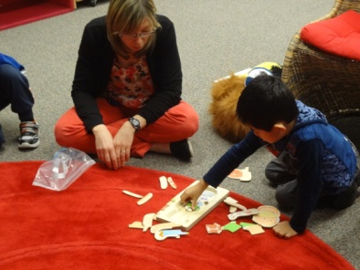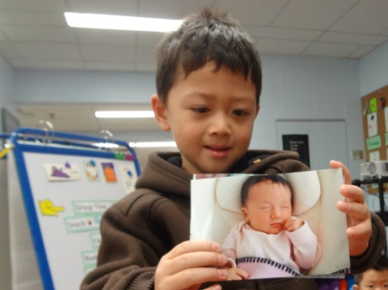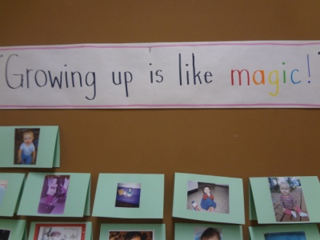
A photo of a new born sibling inspired the class to create an interactive bulletin board display of baby photos. It started with photos of the teachers when they were young. When looking at the teachers’ baby photos, one student exclaimed, “You were teacher babies!” To which another student added, “When you didn’t know how to learn someone before!” Our display quickly included all the class members. One mother said, “We had so much fun! We looked for a baby photo and watched old videos!”
After thinking about the outside of our bodies, we started thinking about what we couldn’t see. A plastic model of a heart was passed around our circle and the children speculated on what they thought it was. Some guesses included: an ear, a foot, and a brain. The teachers explained they did not know what the model was, so they looked through the body books and located images that were similar to find out it was a heart. Together the class watched a video.
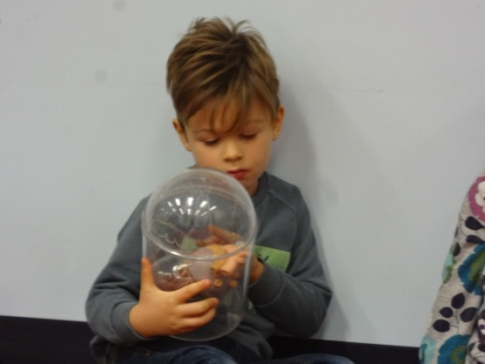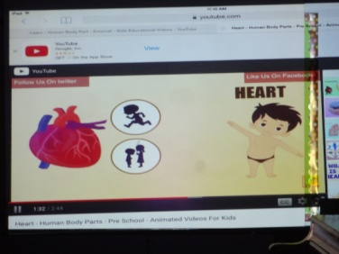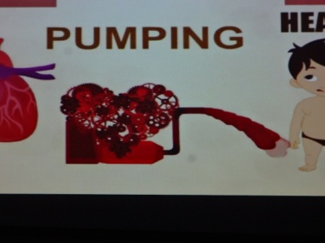
In an effort to explain where the heart was located inside our bodies and how it helped blood oxygenate and flow through the body, a student was traced on paper. At this point the children asked, “Why can’t EVERYONE trace their bodies?” BINGO!!! That was how the children would represent their understanding of bodies. So began the job of tracing everyone’s body onto a large peice of paper. Oh, the excitement!!
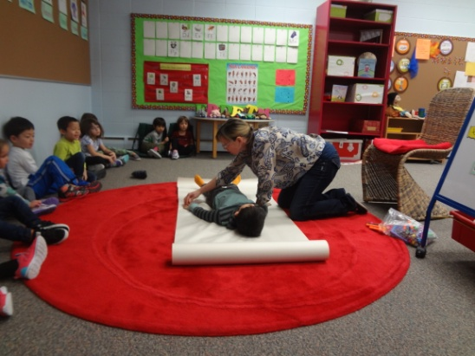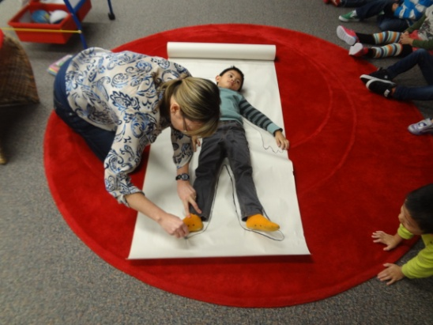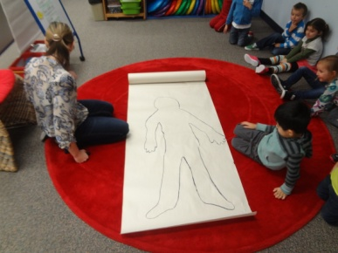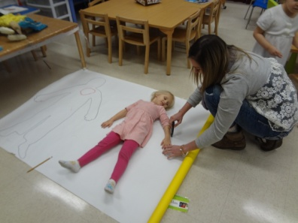
To help guide the children’s representations, they were shown a traced paper body and asked, “What parts of our body could we put on our bodies?” Together the class created a list of seventeen items including: skull, knees, eye lashes, skin and bones. These items were used to create a checklist (the red paper below) -each item had a box, an image and a word. The children consulted the checklist to make a plan before working on their paper bodies, and returned to it to record what they had done. Some children represented their skull and bones, others were interested in facial detail. One child placed a dot near her mouth, and then pointed above her own lip stating, “My freckle!”
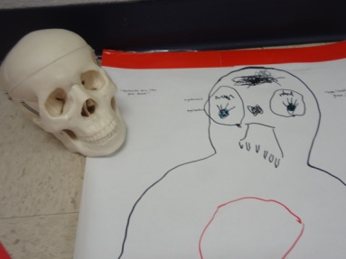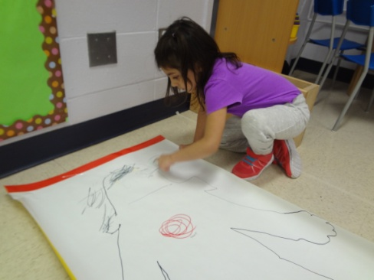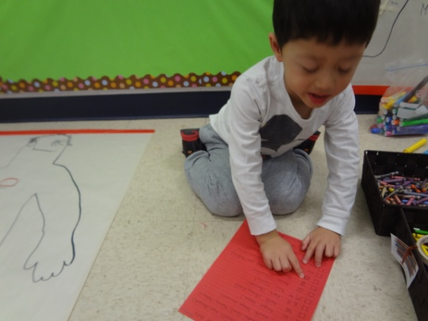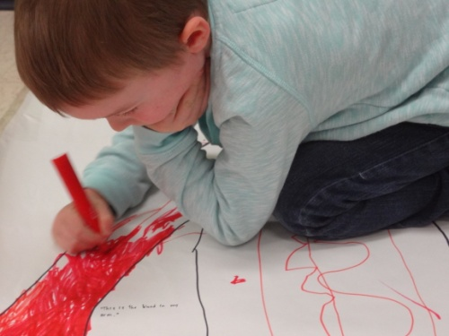
As the children worked on their representations, much was learned about how they were thinking. Some started with their eyes and others with their fingernails. One boy was intent on filling his body with blood – no small project! Another boy who just had dental surgery, closely studied his teeth and then noticed the poster on the wall stating, “It has a broken tooth on it!” This comment created a heightened awareness of teeth, their size, formation, and life cycle! 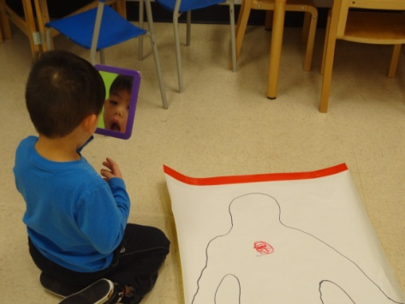 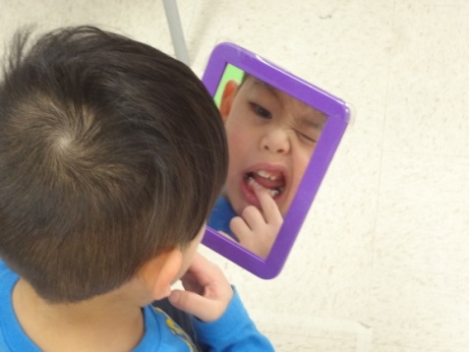 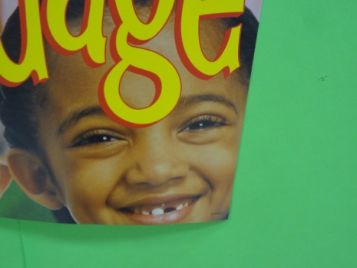 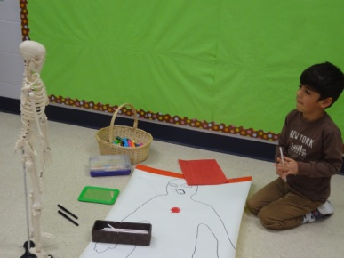
Many children enjoyed the opportunity to show a teacher what they were thinking. For many children, especially those who don’t speak English at home, the activity provided opportunities to inspect and represent aspects of the models. 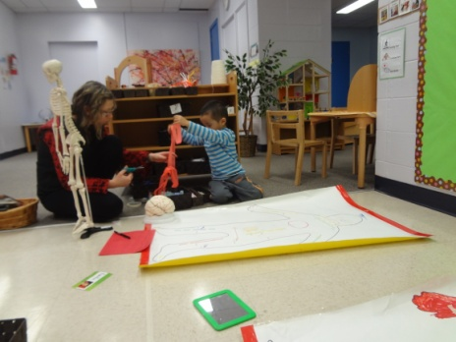 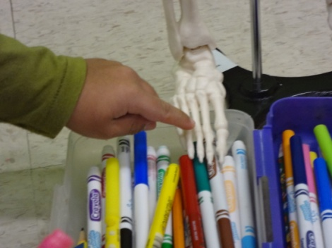 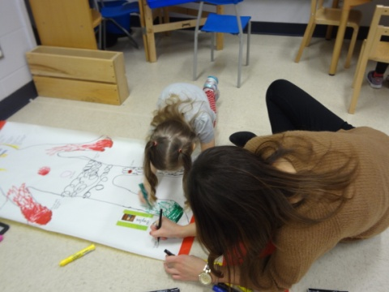 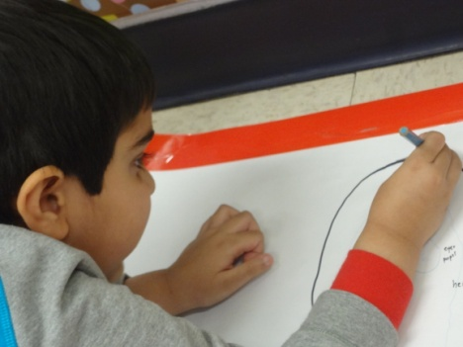

For some children the process of working on their bodies was social, “Do you like the smell of this marker?” For others it was a more independent task.
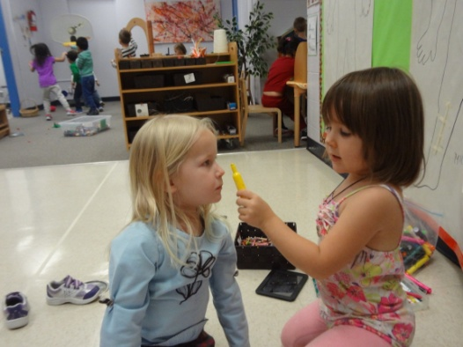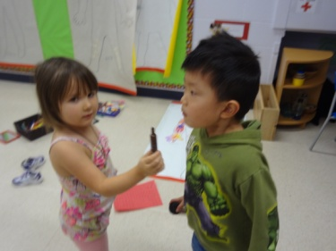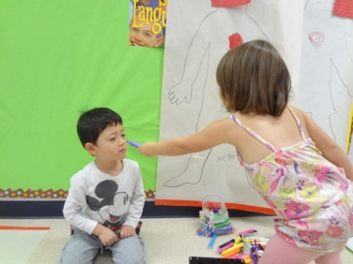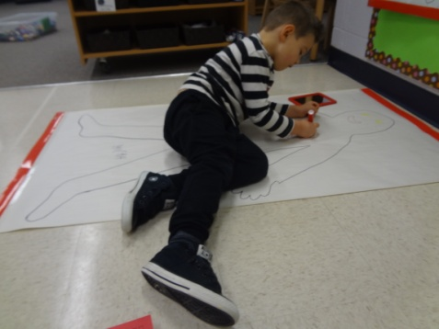
We were quite curious about bones, so a bin of mystery bones was brought out to explore. We could only speculate what kind of bones we were looking at because their origins were unknown!! However, a few bones looked very similar to ones Dr. Patrick McKenna (Chiropractic on Whyte) brought to show us –a femur bone and a rib bone.
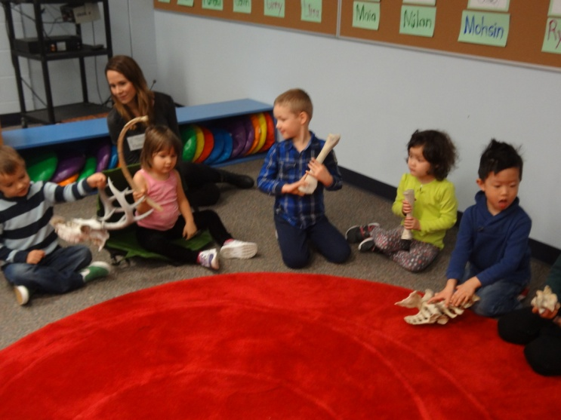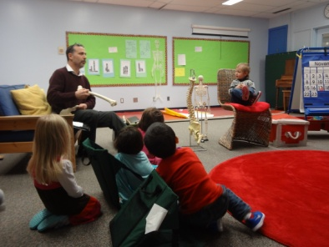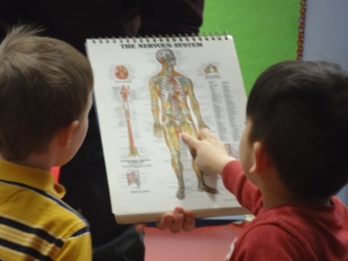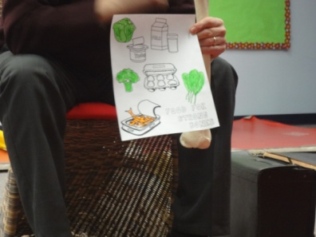
Thanks you Coraline’s family for arranging Dr. Patrick McKenna’s visit. ‘Dr. Pat’, Coraline’s family’s chiropractor, came to visit both the morning and afternoon classes. He showed life size adult bones and explained how they worked to give us form, to make blood, and to protect important soft body parts like the brain, heart, and lungs. He explained that children’s bones grow bigger and stronger while they sleep. This is why it is so important that the children have good, long sleeps each night. Eating healthy food (pictured above) and exercising also help strengthen bones. Dr. Pat explained how our spinal cord is protected by our back bone, and it sends out nerves to all parts of the body. This way the brain can ask different parts of the body to move. To this, someone exclaimed, “The brain is like the teacher of the body!” Dr. Pat was impressed by this insightful comparison! Afterwards, it was the children turn to do a bit of show and share. They showed Dr. Pat our bone collection, had him visit the Doctor’s Office, walked him through the book about broken bones healing, and compared his bones to Mr. Bones!
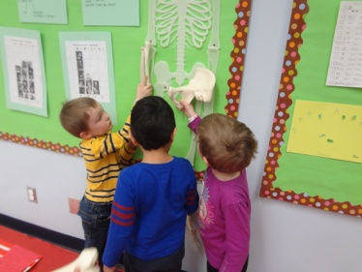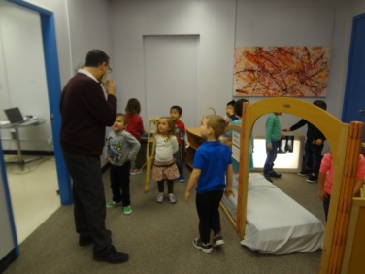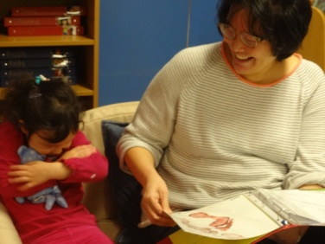
The last part of our inquiry is reflecting on and sharing the learning journey. The Coutts Librarians will be invited to visit our classroom to learn about the inquiry and how we’ve used their models and books. Parents and family members will visit November 26th at our Celebration of Learning, and the JK Directors will view our learning journey on Friday, November 27th.
Reflections & Comments:
Ann: Conducting an inquiry makes me nervous because I don’t know: how it will end, what the children will be interested in, and how they’ll do the representations. The process reminds me to spend more time listening, documenting, photographing, and supporting children’s thoughts. The logistics of using paper bodies was challenging, and at the same time so exciting and personal.

The children said the following when reflecting about the inquiry:
- I liked reading a baby book about how you be borned
- I liked seeing classmates’ show-and-share, ex.: doctor kit
- I liked tracing Mr. Bones
- I liked doing our bodies and feet
- I liked reading the story about germs going in your mouth and then you get sick
- I liked sharing what my baby sister looks like
- I liked tracing my body and putting things in it
- I liked drawing my freckly on my body
- I liked Mr. Bones
- I liked drawing my body
The children were also asked to recall what their parents noticed or said at the Celebration of Learning.
- Where’s the museum? Over there! Oh, there’s your doctor’s bag!
- We played only for an hour in the doctor’s office. I can’t remember what they said.
- We liked the photograph dolls.
- I fixed my Mom with a needle. She almost cried and I said it was already done.
- I showed my Mom the leg, arm, and chest bone.
- Well, I was trying to fix her, but she couldn’t stay there. She got better by healing.
- I showed them (his parents) the bones on my body.
- I showed my Dad the fingernails on my body (the paper representation).
- They said, “Look at your BIG HEART!”
- I showed them the skull!
- I said, “I’ve got bones!!”
The parents were sent an email requesting comments about the body inquiry; here are some of the responses:
Thank you for inviting us to the Celebration of Learning. We were thrilled to see our daughter in action and we’ve heard a lot of bits and pieces of things that now finally make more sense, like taking bunny breaths! I was impressed with the extent of her vocabulary regarding the body inquiry. She picked up bones to show us and was quickly able to identify a skull, X-ray, backbone, teeth, etc. She is normally not a fan of anything having to do with doctors, so we were surprised that she went in the doctor’s office and showed us everything. She doesn’t even like Band-Aids!
Thanks so much for your arrangement for my son’s show time. And it was quiet amazing how much information you gave to the young explorers in such a short time. Really impressive, now my son began to ask me what is inside the head or what is inside the tummy...the questions like those. It for sure opened a door for learning the things that related to him closely. Great work and much appreciated.
Our son loved this segment. He was able to articulate the different bones (animal vs. human and types of the display table when prompted). He showed us around the doctor's office. The baby photo display he was just taken with it! He also chose to read the comic book with "real" elements of how the body works and pointed out the fetus and we talked about digestion as well. Since we have a background in the medical field here at home, we have introduced and talked about the body and body systems at the very start. We have a puzzle at home that is quite advanced but he wants to work on it with me and we will over the holidays and he keeps saying "Oh I know about the body, mummy!" So I'm sure we will be reinforcing the concepts again.

The body inquiry was great. Our son is constantly talking about what he learned at school about the body. It's a great topic because it's something the kids can relate to and are very interested in. He loves to play doctor at home so at the celebration of learning he immediately took on the role of doctor while I was the patient in the school doctor's office. I loved the baby photo display!
Our daughter seemed to enjoy the body inquiry very much. She has been referring to her body parts more frequently than she normally would and has been tracing her hand whenever she has a pencil and clean sheet of paper (and adding purple nail polish of course). With the baby pictures outside of the JK door - she wanted to play the game of naming someone in her class and having me pick them out of the "lineup."
The following representations were carefully prepared and explained by the children. When carefully looking at the images, we hope you see their intellectual study and problem solving demonstrated in their work.
The children had a list of items they had created, items they may wish to represent: skin, eyes, eye lashes, belly button, tummy, mouth, tongue, teeth, ears, hair, brain, skull, jaw, hands, fingernails, bones, feet, knees, and butt. Their representations indicate what is important to them, or when they find intersting or beautiful. For some they choose to feature what people comment on, like “gaint eyes and big eye lashes,” “a big heart” or “robot teeth.” These representations capture what the children were thinking: They’re more than “cute!”

